Detroit Police Department:

Patrol Resource Management

DSA/DSB/DSE 7500 Practicum

Summer 2025



Adanna Smith

Eugene Lowe

Katrina Skiotys

Ahmad Hamood

Eriyon Adams

# Table of Contents

Table of Contents 2

Introduction 3

Initial Topics/Dashboard Topics Overview 3

Literature Review 3

Response Time and Crime-Resource Correlation 3

Officer Wellness and Unit Workload 4

Deployment Cost Projection 4

Data Processing 5

Data Summary 5

Data Cleaning 5

Analysis 6

Results 7

Main Dashboards Used in Final Results 7

Conclusion 8

Future Research Opportunities 8

Prepared Dashboards 8

Proposed Research Extensions 8

References 9

Appendix 10

# Introduction

Patrol management in police work involves organizing, directing, and overseeing the deployment of officers to ensure effective coverage, rapid response, and public safety. It is important because it helps deter crime, ensures efficient use of resources, and builds community trust through visible law enforcement presence. This project aims to assist the Detroit Police Department in enhancing patrol deployment strategies, evaluating resource distribution, and supporting operational decision-making.

## Initial Topics/Dashboard Topics Overview

* **Response Time and Crime-Resource Correlation**: Highlights delayed 911 responses and compares them with crime rates and unit availability. Flags outliers by call type, shift, and unit to support more efficient patrol coverage.
* **Officer Wellness and Workload Monitoring**: Tracks overtime, shift frequency, and consecutive deployments to identify fatigue risks. Highlights workload imbalance to support more equitable scheduling.
* **Deployment Cost Projection**: Allows users to simulate patrol staffing, overtime, and vehicle scenarios. Provides instant cost feedback to guide resource planning and budget decisions.
* **Real-Time Incident Monitoring (Optional)**: Displays near-live dispatch, alert, and vehicle activity to enhance situational awareness. Supports quicker command response during high-priority events.

# Literature Review

## Response Time and Crime-Resource Correlation

Police response time is a vital measure of effectiveness, impacting crime resolution and public trust. The Detroit Police Department (DPD) uses data-driven tools—like dashboards and geospatial mapping—to improve response efficiency by identifying patrol gaps and better allocating resources (Detroit Police Department, n.d.). This reflects broader trends in adaptive, data-informed policing.

A scoping review by Watson, Miller, and Adams (2023) of 630 studies identified key factors affecting response time: geography, call type, staffing, and scheduling. They emphasized the value of dynamic analytics in improving clearance rates. Salimbene and Zhang (2020) found that larger departments respond faster, but variables like call severity and ethnic diversity can delay responses—highlighting systemic and equity-related challenges in service delivery.

Langton et al. (2023) analyzed over 260,000 DPD calls, revealing that only 44% were crime-related, with significant officer time spent on traffic, quality-of-life, and public health issues. This underscores the need for data-driven deployment that accounts for a broad range of community demands. Sui et al. (2025) developed an AI-based patrol optimization model, improving response efficiency through real-time route adjustments. Their multi-objective algorithm demonstrates promise for cities like Detroit facing complex deployment challenges. DPD’s integration of public feedback and transparency dashboards aligns with best practices for managing response times (Detroit Police Department, n.d.).

## Officer Wellness and Unit Workload

Officer wellness is key to sustainable policing. Chronic stress and heavy workloads increase burnout, mental health risks, and reduce performance. PowerDMS (2025) advocates early intervention systems to monitor workload and prevent burnout. The 2024 Law Enforcement Officers Safety and Wellness Study links job stress to PTSD, depression, and sleep issues, while showing that wellness resources and resilience training can help—though stigma remains a barrier. Martinez, Johnson, and Lee (2023) support systematic tracking of assignments to balance workload, improve job satisfaction, and boost retention. Thompson, Garcia, and Roberts (2023) identify four pillars of effective wellness programs: prevention, supportive culture, ongoing training, and accessible care. However, inconsistent implementation remains a challenge. Together, these studies call for integrated wellness monitoring to enhance both officer health and public safety.

## Deployment Cost Projection

Sustainable resource allocation is critical. DPD’s 2020 Improvement Plan uses financial dashboards to track staffing, overtime, and equipment costs, aiming to improve efficiency (Detroit Police Department, 2020). Yet, a report by the Center on Juvenile and Criminal Justice (2024) found that rising investments haven’t improved crime clearance, pointing to the need for smarter, not just more, spending. The Washington State Institute for Public Policy (2024) showed that targeted hot spot policing can yield high returns—about $491,000 per added officer—with a 5.32:1 benefit-to-cost ratio. Investments in training technologies like de-escalation and active shooter simulators (costing $100K–$500K) are increasingly justified by their impact on preparedness and reduced violence (Walker, 2016). In sum, strategic deployment paired with cost-effective investment and training is essential for maximizing both fiscal and operational outcomes.

# Data Processing

## Data Summary

• **Detroit Police Department**

* CAD Patrol – 1 Month: 911 dispatch and unit activity
* CAD Patrol – 6 Month: 911 dispatch and unit activity
* CAD Out of Service – 1 Month: Captures true unit downtime
* CAD Unit History – 1 Month: Records shift boundaries
* CAD Unit List: Links unit codes to assigned roles
* Nature Codes List: Describes crime types
* Out-of-Service Codes List: Details reasons for unit unavailability
* Platoon Schedule: Outlines shift assignments
* Vehicle Cost Logs

• **City of Detroit – Open Data Portal**

* 911 Calls
* Crime Incidents
* DPD Precincts
* DPD Scout Car Areas (beats)

Due to inconsistencies in how duration is recorded across datasets, comparisons should be approached cautiously. The dataset is selective in nature, focusing on specific incident types and conditions, with analysis conducted at both the precinct and scout car levels. Data is typically evaluated on a 28-day cycle.

## Data Cleaning

Initially, the 911 Calls and Crime Incidents datasets from the City of Detroit’s Open Data Portal were used to create preliminary dashboards and explore storytelling opportunities through data. These worksheets helped shape the focus areas for our project. Based on that work, the Detroit Police Department (DPD) provided additional CAD datasets tailored to our selected topics.

Several steps were taken to clean and prepare the data for analysis. The one-month DPD CAD datasets were unionized in Tableau to allow for better integration. Unit codes such as "desk," "other," and similar variants were removed during the cleaning process. For the six-month CAD Patrol dataset, only calls with sources listed as E911, W911, or PHONE were included. Priority 1 calls were excluded to maintain focus on non-violent incidents. Vehicle cost fields were converted from string to numeric format to enable accurate calculations.

While early phases involved unionized data, the final dashboards and DPD-facing presentation relied more heavily on joined datasets to align insights across sources. The analysis emphasized precinct-level trends rather than beat-level details to better reflect DPD’s operational priorities. A wide range of calculated fields were created to support the development of the final dashboards and insights.

# Analysis

This project began with the creation of 17 exploratory dashboards to investigate patterns in response time, call volume, unit activity, and deployment outcomes across all 11 Detroit Police Department precincts. The dashboards were developed through iterative filtering, calculated fields, and geographic mapping to reveal trends that are not immediately visible in raw datasets.

* The Beat Balance Index Dashboard reveals workload imbalances by highlighting high-activity beats hidden in precinct-level averages (see Appendix A).
* The DPD Workload and Median Responsiveness dashboard focuses on response times and call volume for the different DPD precincts (see Appendix B).
* The Response Time and Resource Correlation dashboard omitted crime type and priority 1 crimes seen in the previous iteration and explored how unit availability and deployment influence precinct-level response delays using multi-month and April datasets (see Appendix C).
* The Deployment Cost Projection dashboard allows users to simulate patrol staffing levels, vehicle usage, and overtime to assess budget impacts and cost-per-call efficiency (see Appendix D).
* The DPD Unit Efficiency and Resource Utilization Index dashboard highlights workload distribution and unit performance across the city, comparing coverage, calls handled, and overall deployment equity (see Appendix E).
* The Response Time and Crime-Resource Correlation dashboard integrates spatial analysis of delayed calls with crime incidents to examine alignment between public safety demand and resource availability (see Appendix F).
* The out-of-service analysis depicts which OScodes are deemed routine vs. non-routine. Hours out-of-service were then compared based on the two distinctions. (see Appendix G).

# Results

### Main Dashboards Used in Final Results

**1. Response Time and Crime Resource Correlation Dashboard**  
Examines delay percent (over 15 minutes), median response time, call type mix, and available units by precinct, shift, and date range so leaders can isolate where demand exceeds capacity and where crime related calls compete with other service requests.

* **Out-of-Service (OOS) Analysis:** Looks at how OOS frequency impacts operational efficiency and response times. Although Precinct 3 has a higher number of scout cars that went out of service, it maintains a lower Out-of-Service to On-Duty ratio. This ratio—calculated by dividing the number of OOS scout cars by those on duty—standardizes the data and provides a clearer, more accurate comparison of OOS impact across precincts. Vehicles from precinct 3 being low to non-operational due to their low deployment and high OOS hours should be repaired and repurposed to precinct 8, providing more resources to them which could aid in their response times.

**2. Deployment Cost Projection Dashboard**  
Models how changes in unit and caller precincts and vehicle availability influence operating cost and response readiness; supports scenario planning before reassigning units or altering shift structures.

This analysis combines six months of patrol response data with April 2025 patrol and unit records to evaluate how Precincts 3 and 8 manage comparable workloads. Both precincts handled more than 10,000 calls, yet Precinct 3 consistently recorded lower delay rates. Precinct 3 maintained delay rates between 35 and 40%, supported by 50 to 65 daily units drawn from two platoons, which provided broad shift coverage and increased geographic flexibility.

Precinct 8 recorded the highest delay rate among all precincts, with nearly 60% of its calls exceeding the 15-minute response threshold. A delay was defined as any response taking more than 15 minutes from call time to first arrival. It operated with just 25 to 30 daily units and relied mostly on a single platoon, limiting its capacity to adjust coverage across time or areas. In April alone, Precinct 8's median delay was 177 minutes compared to just 101 minutes in Precinct 3. These differences suggest that patrol structure and deployment strategy play a more significant role in outcomes than staffing volume alone.

Assist data further reinforces these patterns. Precinct 3 received the highest volume of external support in April, about 19,000 units from almost every precinct. Meanwhile, Precinct 8 only received heavy assistance from one other precinct despite having a similar workload to Pricinct 3. This dynamic points to Precinct 3 as a high-demand service area requiring sustained support, while Precinct 8 was left to handle its own workload largely by its own efforts. These findings emphasize the importance of inter-precinct coordination, platoon diversity, and structural flexibility in ensuring equitable and timely response.

* **Vehicle cost analysis:** Highlights vehicles where maintenance costs substantially exceed fuel costs. Vehicles with such operational issues should either be given more attention to providing more permanent repairs or look to replace vehicles if the budget allows. A large concentration of scout cars lie between the $0 - $500 range for maintenance costs, and $0- $400 range for fuel costs.

# Conclusion

This project underscores the critical role of data-driven insights in enhancing patrol management for the Detroit Police Department. By analyzing response times, workload balance, deployment costs, and operational efficiency across precincts, the dashboards developed provide actionable guidance for optimizing patrol strategies. The comparison between Precincts 3 and 8 highlights how structural flexibility, inter-precinct support, and balanced platoon deployment can significantly reduce delays, even when call volumes are comparable. Moreover, the inclusion of cost modeling supports resource planning. These findings emphasize the need for ongoing monitoring, targeted investments, and adaptive scheduling to improve response equity and public safety outcomes citywide.

# Future Research Opportunities

## Prepared Dashboards

To support the exploration of future research topics and operational improvements, two sets of Tableau dashboards were developed using Computer-Aided Dispatch (CAD) datasets:

* **Unit Status Dashboard** (see Appendix H): Also built using three-month CAD data, this dashboard visualizes total calls by precinct and unit status by shift (midnight, afternoon, day).
* **Incident Change Dashboard** (see Appendix I): Uses six-month CAD Patrol data to examine how incident types evolve during a call.
* **Out of Service Trends Dashboard:** Use the CAD Out of Service dataset to examine the trends of out of service vehicles.

## Proposed Research Extensions

To ensure continued progress and address emerging challenges, the following areas are recommended for further analysis and discussion:

* **Call Closure Timing:** Examine how long it takes for calls to be closed in the system and whether there are delays during shift or platoon transitions.
* **Out-of-Service Pattern Analysis:** Analyze how long scout cars remain out of service and identify patterns by time of day (especially midday), day of week, or staffing levels.
* **Out-of-Service Reason Prioritization:** Work with DPD to determine which Out-of-Service codes reflect actual operational disruptions versus routine or low-risk statuses.

# References

Bluewater Technologies. (n.d.). Detroit Police Real-Time Crime Center. <https://bluewatertech.com/portfolio/detroit-police-rtcc/>

Center on Juvenile and Criminal Justice. (2024, February 13). California law enforcement agencies are spending more but solving fewer crimes. <https://www.cjcj.org/reports-publications/report/california-law-enforcement-agencies-are-spending-more-but-solving-fewer-crimes>

Chicago Police Department. (n.d.). Police Observation Device (POD) Cameras. <https://www.chicagopolice.org/police-observation-device-pod-cameras/>

Detroit Police Department. (n.d.). Police Department. <https://detroitmi.gov/departments/police-department>

Detroit Police Department. (2020). 2020 Improvement Plan. <https://detroitmi.gov/sites/detroitmi.localhost/files/2020-12/2020%20Improvement%20Plan.pdf>

Langton, L., Ratcliffe, J., & Lum, C. (2023). Describing the scale and composition of calls for police service: A replication and extension using open data. *Policing: An International Journal*, <https://doi.org/10.1080/15614263.2022.2102494>

Law Enforcement Officers Safety and Wellness Study. (2024). Law enforcement officers safety and wellness: A multi-level study. <https://www.ojp.gov/pdffiles1/nij/grants/308781.pdf>

Lee, J., Kim, H., & Park, S. (2024). Design of a real-time crime monitoring system using deep learning techniques. *Journal of Computational Intelligence and Applications*, 15(2), 45–62. <https://www.sciencedirect.com/science/article/pii/S2667305323001369>

Martinez, A., Johnson, R., & Lee, S. (2023). The feasibility of workload monitoring among law enforcement officers: A multi-methodological approach. *Police Quarterly*. <https://pubmed.ncbi.nlm.nih.gov/38154228/>

Nguyen, T., Smith, D., & Wang, L. (2023). Cyber-physical-social awareness platform for comprehensive situation awareness. *Sensors*, 23(2), 822. <https://www.mdpi.com/1424-8220/23/2/822>

PowerDMS. (2025). Why police early intervention systems are critical for officer wellness. <https://www.powerdms.com/policy-learning-center/why-police-early-intervention-systems-are-critical-for-officer-wellness>

Salimbene, S., & Zhang, J. (2020). An examination of organizational and community effects on police response time. *Policing: An International Journal of Police Strategies & Management*, 43(3), 560–579. <https://www.emerald.com/insight/content/doi/10.1108/pijpsm-04-2020-0063/full/html>

Sui, Y., Zhang, H., & Wang, J. (2025). Optimizing police patrol strategies in real-world scenarios: A modified PPS-MOEA/D approach for constrained multi-objective optimization. *Applied Sciences*, 15(7), 3651. <https://doi.org/10.3390/app15073651>

Thompson, L., Garcia, M., & Roberts, K. (2023). Are organizational responses by police forces appropriate to adequately safeguard police officer wellness? A review of the scientific evidence. *Safety Science*, 158, 105–123. <https://www.emerald.com/insight/content/doi/10.1108/sc-05-2023-0015/full/html>

Washington State Institute for Public Policy (WSIPP). (2024). Deploy one additional police officer with hot spot strategies. <https://www.wsipp.wa.gov/BenefitCost/Program/236>

Walker, T. (2016). Police departments investing in de-escalation, active shooter simulators. *WXYZ*. <https://www.wxyz.com/news/national/police-invest-in-de-escalation-active-shooter-simulator>

Watson, C., Miller, J., & Adams, R. (2023). Predictors of police response time: A scoping review. *Journal of Criminal Justice Studies*, 18(4), 315–333. <https://link.springer.com/article/10.1186/s40163-023-00194-3>

# Appendix

Appendix A: Beat Balance Index

Appendix B: DPD Workload and Median Responsiveness Dashboard

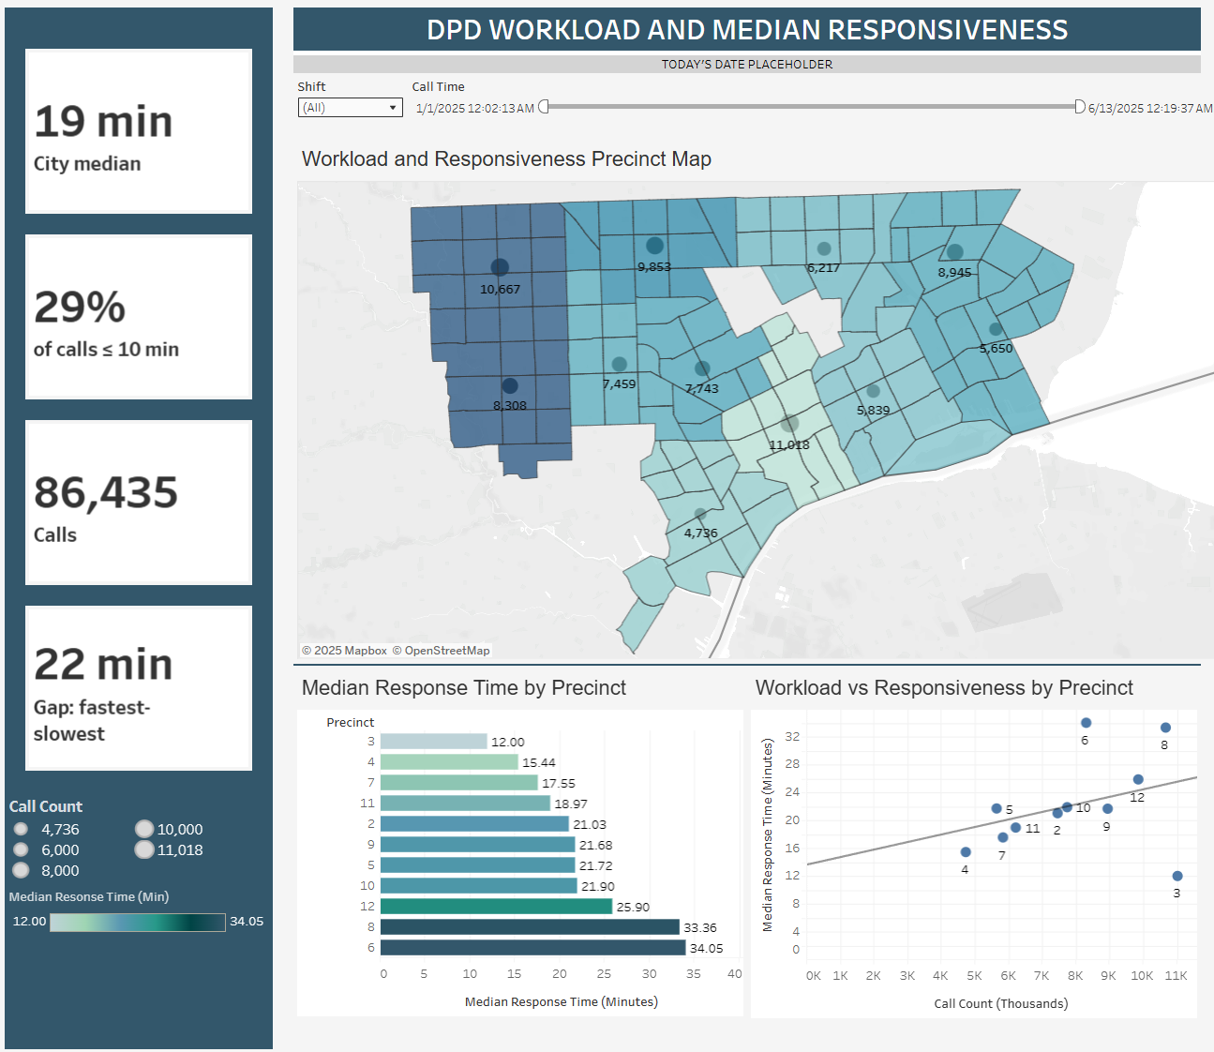

Appendix C: Response Time and Resource Correlation Dashboard

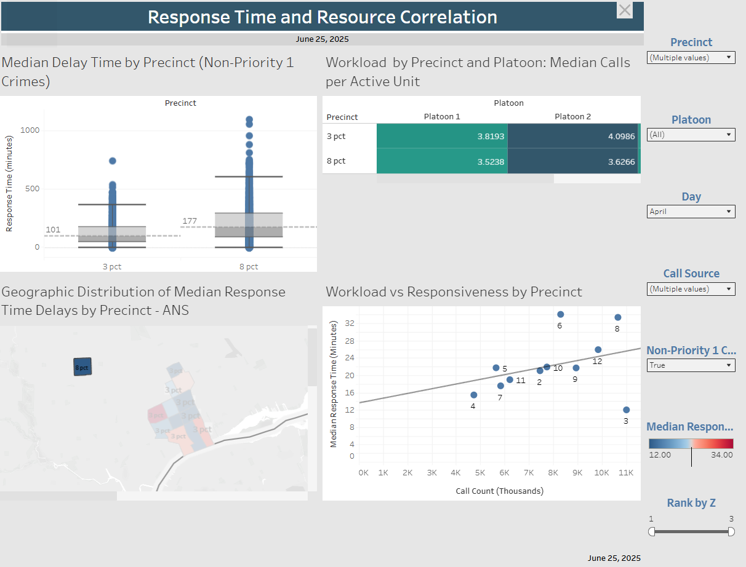

Appendix D: Deployment Cost Projection (April)

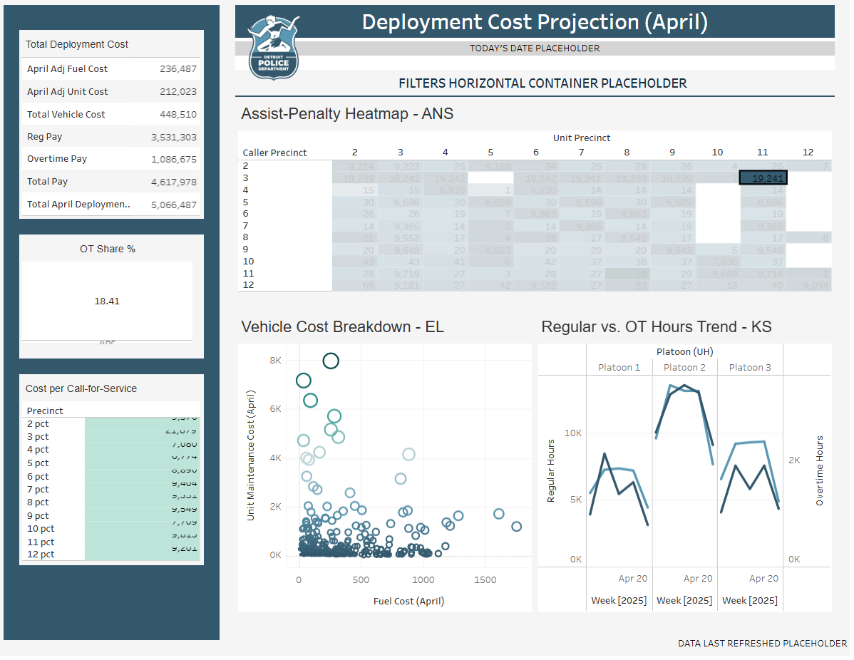

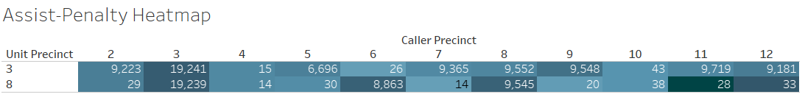

Appendix E: The DPD Unit Efficiency and Resource Utilization Index Dashboard

Appendix F: DPD Response Time and Crime-Resource Correlation Dashboard (Initial and Updated)

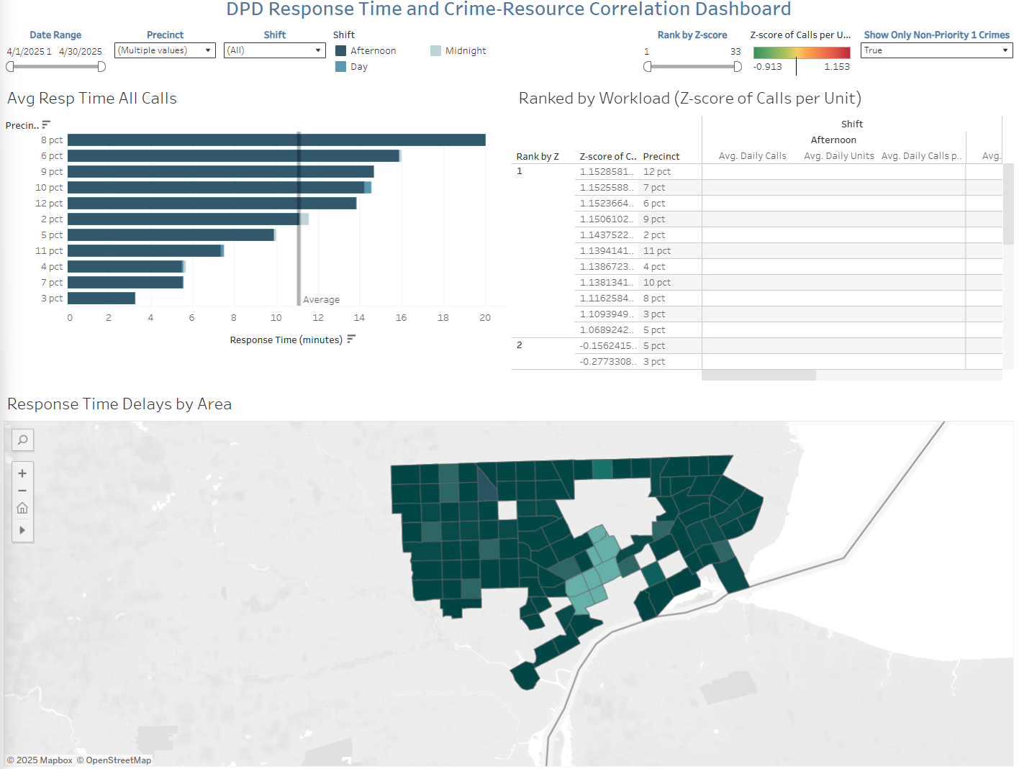

Appendix G: Non-Routine OOS Frequency (April)

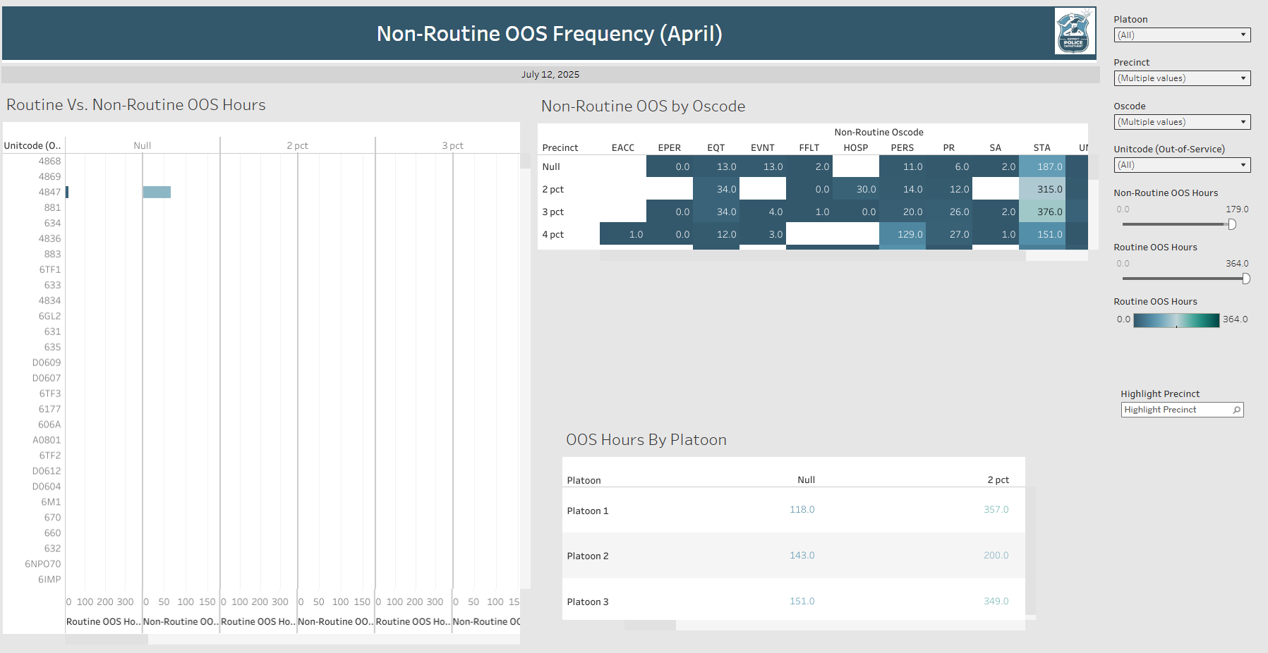

Appendix H: Unit Status Dashboard

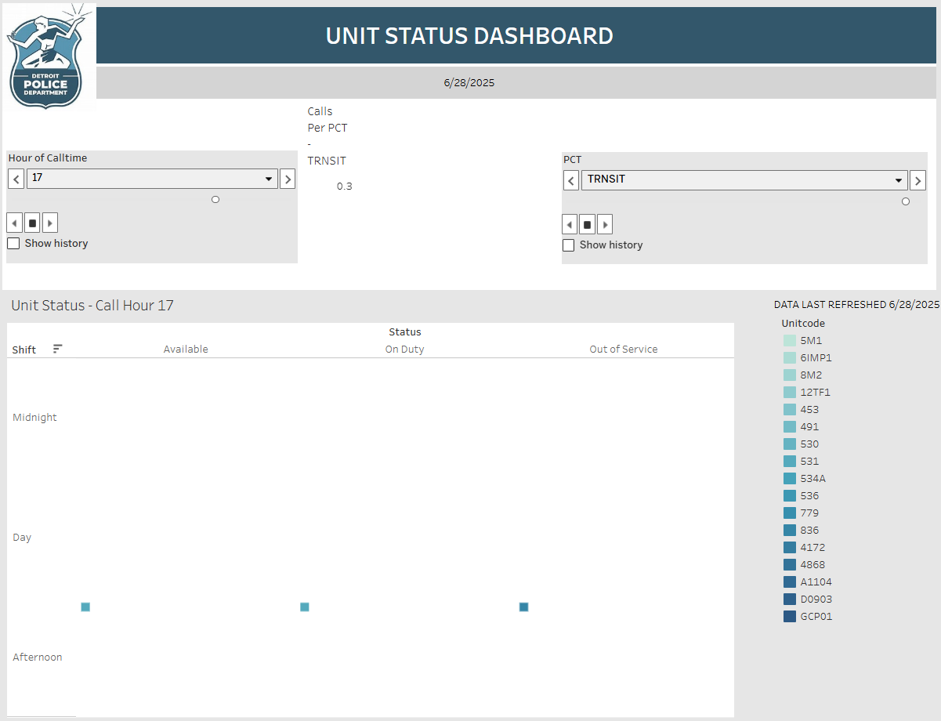

Appendix I: Incident Change Trends

